DO IT – Front End developer

Section 4 - Additional Assignment – Typescript web application

SMART d.o.o, New Frontier Group

Version: 1.0

Revision date: March 23, 2018

Table of Contents

Specification of assignment 2

Requirements for this assignment 3

Tasks 4

Timeline 5

Tools 6

# Specification of assignment

During this assignment you are going to make TypeScript web application using screenshots below.

# Requirements for this project

Before you can start with this project you will need to know how to work in Windows 7 OS. You will need average expirience in Windows 7 OS . You need to know how to use Visual Studio Code. You will use GIT commands for this assignment.

You need to finish all Typescript courses, and you will need to use additonal help from internet resources.

**Task**

1. Create web application using Typescript, HTML5 , CSS 3.
2. Make application same as on pictures below
3. Make login screen as on picture 1

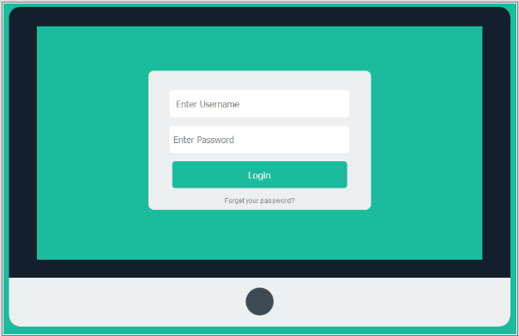

Picture 1.

1. If you are not registered show message as on picture 2

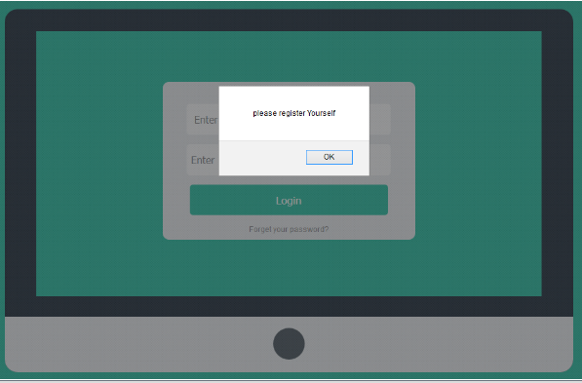

Picture 2

1. Make registration form same as on picture 3

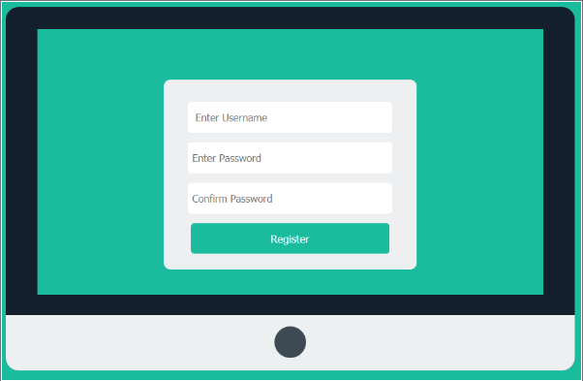

Picture 3

1. If data is not insert correctly (you choose what is correct) show mesage as on picture 4

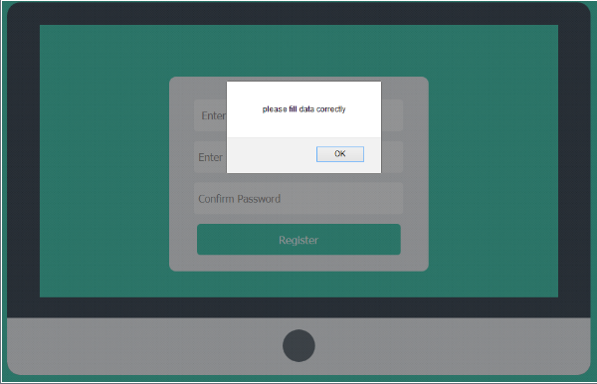

Picture 4

1. If you enter incorrect password show message as on picture 5

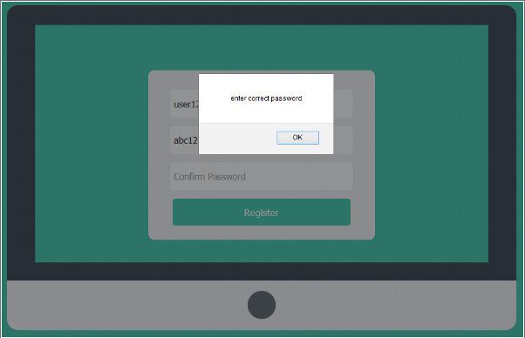

Picture 5

1. If you register correctly show message as on picture 6



Picture 6

1. After successfully login page should look like picture 7

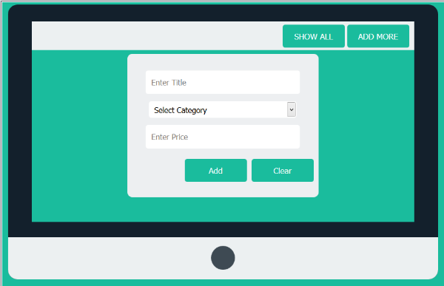

Picture 7

1. Category can contain different tpes (you choose which one), Price need to be in numbers ,title in string (see picture 8)

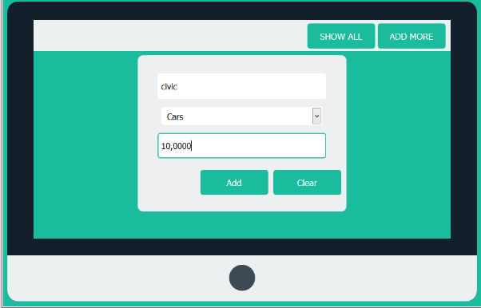

Picture 8

1. When you click Add button you need to output mesage as on picture 9

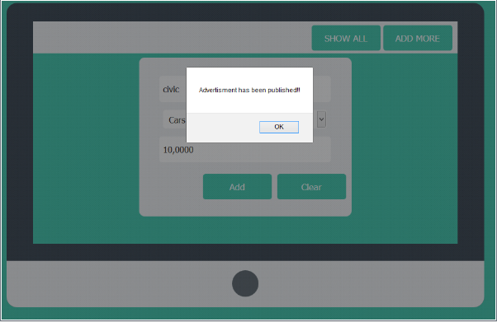

Picture 9

1. When you click on Show All button , it will show all added advertisments

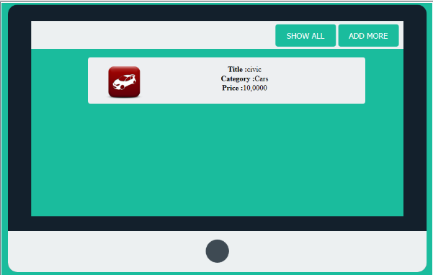

Picture 10

1. Additional Task : Implement Logout button ,and display logged username in header
2. For all messages you can use Toastr library. You need to make custom CSS , with SASS.

# Timeline

You will have 2 days to finish this job.

# Tools

## IDE and Source Control

You will use Windows 7 OS for this assignment. If you wish you can use Visual Studio Code. You need to use GIT Bash in this assignment.